School Closure Daily Planning- Garnet Class
DATE | Reading | Writing | Mathematics | Topic
Tuesday  26.1.21 | Ask questions to understand the text.  Pandora’s Box  Read the text again and  highlight unknown words what could they mean? Discuss: what the text is about? Why do you like/dislike the text?  Hot seating  Can you take on the role of Pandora or Zeus –is there someone near you who could ask you questions such  - Why you have acted in the way that you have  - What you would do differently next time  - How you could have helped in the story.  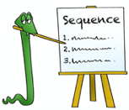 | All about Greek gods and goddesses  Watch the PowerPoint and find out about some of the Greek gods and goddesses.  Please research 3-4 of the Greek gods and goddesses –remember you can use the PowerPoint too for information.  You can record your information on the sheet or ceate your own fact file.  Find additional information at:  https://www.bbc.co.uk/bitesize/topics/z87tn39/articles/zgt7mp3 | Key mathematical vocabulary  1.Watch the video recapping on key vocabulary and practising stem sentences.  White Rose  2.True or false  3Multiply three numbers  Please Watch the video and complete the work sheets.  https://whiterosemaths.com/homelearning/year-4/week-1-number-multiplication-division/  Extension  Reasoning and problem solving question. | Cricket  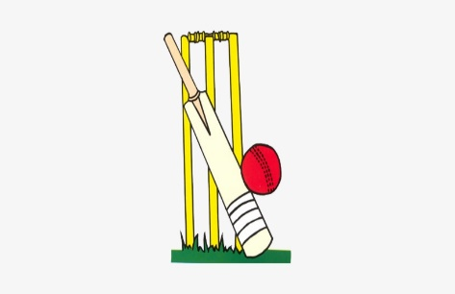  Chance to shine second cricket lesson  Please follow the link to:  https://www.youtube.com/watch?v=uYyvkI0tpnk  And/or  Creative activity  Imagine you have the opportunity to create your very own god or goddess. Can you think of powers they might have, what they may be the god/goddess of, an animal they might have or a means of transport. Can you draw your Greek god/goddess and label your design showing their strengths and powers?  https://www.ducksters.com/history/ancient_greek_mythology.php

https://www.literacyshed.com/story-starters.html
Online dictionary -https://kids.wordsmyth.net/we/

Maths ideas:
Pixl –practise tables using the App
Nrich -https://nrich.maths.org/primary
Worksheets to practise tables: http://www.snappymaths.com/

Keeping active:
Cosmic kids yoga –mainly on Youtube check with an adult
GoNoodle -https://app.gonoodle.com/
The Woodland trust - https://www.woodlandtrust.org.uk/support-us/act/your-school/resources/
Joe Wicks daily work out

CBBC: has lots of programmes from ‘Horrible Histories’ to ‘Operation Ouch’

