School Closure Daily Planning- Garnet Class
DATE | Reading | Writing | Mathematics | Topic
Thursday  21.1.21 | Retrieving information from the text  Can you use your retrieval skills to find the information?. To achieve this you need to find information from from the text to answer a question.  Extension  Could you write a question for someone else to answer? | Write haiku with a wintry theme  Can you remember writing a harvest haiku? Can you remember what is is? Watch my lesson on SeeSaw to find out how to write your poem.  Look at the template –can you make a list of adjectives and other wintry words and then start to plan your haiku.  How about this line to get you started..  Winter is coming  Can you write two haikus and decorate your work with a winter scene. | Perimeter of a rectangle  https://whiterosemaths.com/homelearning/year-4/week-9-measurement-length-perimeter/  Please click on the link to watch the video on ‘Perimeter of a rectangle’ and complete the work sheets.  Extension sheets  These are reasoning and problem solving sheets linked to the topic on perimeter. | Chance to shine cricket.  Please follow the link for the lesson. 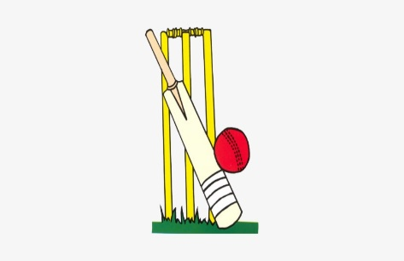  https://www.youtube.com/watch?v=CflrJ4y-Z7g  The session looks at bowling, batting and catching skills and advice on alternative equipment.

https://www.literacyshed.com/story-starters.html
Online dictionary -https://kids.wordsmyth.net/we/

Maths ideas:
Pixl –practise tables using the App
Nrich -https://nrich.maths.org/primary
Worksheets to practise tables: http://www.snappymaths.com/

Keeping active:
Cosmic kids yoga –mainly on Youtube check with an adult
GoNoodle -https://app.gonoodle.com/
The Woodland trust - https://www.woodlandtrust.org.uk/support-us/act/your-school/resources/
Joe Wicks daily work out

CBBC: has lots of programmes from ‘Horrible Histories’ to ‘Operation Ouch’

