School Closure Daily Planning- Garnet Class
DATE | Reading | Writing | Mathematics | Topic
Thursday  14.1.21 | Infer, retrieve, summarise, compare and explain meaning  Can you retrieve information from the text on Shackleton to find the answers to the questions?  Can you mark your answers too? | 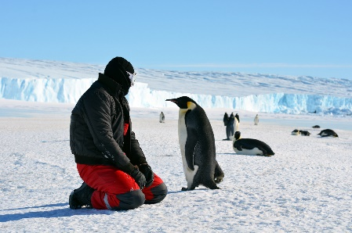  Antarctica:Teachers in the Freezer  https://www.stem.org.uk/elibrary/resource/31005  Can you watch the video about a group of British teachers who go on a four-week expedition to Antarctica.It really helps to show the environment and how animals and humans adapt to the conditions.  Imagine you get the chance to go to Antarctica. Can you write a letter home describing the weather, the conditions and your thoughts and feelings about the experience  Checklist for writing your letter:  I can write the address of the person who it is to  I can include the date  I can write who the letter is to  I can include interesting facts about Antarctica  I can write about how I am feeling  I can describe the weather and conditions  I can join my letters and think about presentation  I can think about how to end my letter. | White Rose Maths – please watch the video on ‘Add lengths’ and complete the worksheets.  https://whiterosemaths.com/homelearning/year-4/week-8-measurement-length-perimeter/  More maths…  If you would like more mathematical challenges try Nrich- Lengthy journeys  https://nrich.maths.org/6051  There are ideas to help get you started and some possible solutions too. | Shadows  Please follow the link to: https://www.science-sparks.com/shadow-activity-ideas/  Recap on transparent, translucent and opaque materials and scroll down to find activities linked to shadows.  Can you have go at one of the suggestions?  You can:  - Make another shadow frame  - Draw shadows –and watch them change on a sunny day  - Change the size of shadow people  - Make a shadow puppet  - Create and draw shadow sculptures

More ideas to help with home learning
Writing ideas:
https://www.literacyshed.com/story-starters.html
Online dictionary -https://kids.wordsmyth.net/we/

Maths ideas:
Pixl –practise tables using the App
Nrich -https://nrich.maths.org/primary
Worksheets to practise tables: http://www.snappymaths.com/

Keeping active:
Cosmic kids yoga –mainly on Youtube check with an adult
GoNoodle -https://app.gonoodle.com/
The Woodland trust - https://www.woodlandtrust.org.uk/support-us/act/your-school/resources/
Joe Wicks daily work out

