School Closure Daily Planning- Garnet Class
DATE | Reading | Writing | Mathematics | Topic
Monday 1st February  1.2.21 | Read and understand a text  Please listen to me read the text for this week, ‘Facts about Greece’  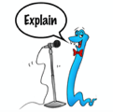  Can you have a go at ‘Echo Reading’. You can pause the video as you go along.  Echo Reading  In echo reading the teacher reads a short segment of the text –this could be a sentence or a short paragraph and the students echos it back. | The Oak Academy spellings  Please follow the link to find out how to use suffixes in the past tense.  https://classroom.thenational.academy/lessons/to-investigate-suffixes-past-and-present-tense-60up6e  Some of the Statutory spellings too  - Decide  - Describe  - Different  Can you check any definitions you are not sure about and use the spelling ideas grid to practise too. | Pixl maths test  Please choose the one that suits you best.  Please complete the Pixl test  Spring week 2 and mark your answers. Please remember to have another attempt at any that may need correcting.  Mathletics  Please complete the assignments ‘Mental Maths’ and ‘Related Facts’ . Remember, you can choose whether to complete harder or easier options.  Tables  Practise using the Pixl App  Practise sheet –choose the one for you. | The Oak Academy  Find out about the role of an archaeologist and how we know so much about Ancient Greece  https://classroom.thenational.academy/lessons/why-do-we-know-so-much-about-ancient-greece-75h6ce  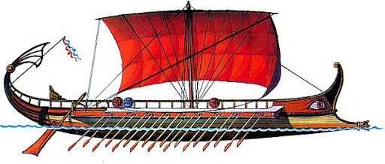  Additional research on the Greek Army and battles at sea  https://www.bbc.co.uk/bitesize/topics/z87tn39/articles/zckr4wx  Extension  Follow the link to see a Greek Warship called a Trireme. Can you draw and label your ship?  https://www.dkfindout.com/uk/history/ancient-greece/trireme/

English ideas
https://www.literacyshed.com/story-starters.html
Online dictionary -https://kids.wordsmyth.net/we/

Maths ideas:
Pixl –practise tables using the App
Nrich -https://nrich.maths.org/primary
Worksheets to practise tables: http://www.snappymaths.com/

Keeping active:
Cosmic kids yoga –mainly on Youtube check with an adult
GoNoodle -https://app.gonoodle.com/
The Woodland trust - https://www.woodlandtrust.org.uk/support-us/act/your-school/resources/
Joe Wicks daily work out

CBBC: has lots of programmes from ‘Horrible Histories’ to ‘Operation Ouch’

