School Closure Daily Planning- Garnet Class
DATE | Reading | Writing | Mathematics | Topic
Friday 22.1.21 | Using our reading skills to make inferences  Today we are looking at inference. This is when you use evidence provided by the author to draw your own conclusions. Often, we have to use the information the author gives us to work out things for ourselves. This is using inference skills | Punctuation lesson: to explore the function of apostrophes  from The Oak academy  https://classroom.thenational.academy/units/t3-punctuation-level-objectives-b1b0  Can you follow the link and complete the questions from the Oak academy.  Extension  Missing apostrophes  Can you complete the work sheets? | Perimeter of a rectilinear shape  Rectilinear definition:  This is a shape where all the sides meet at right angles.  https://whiterosemaths.com/homelearning/year-4/week-9-measurement-length-perimeter/  Extension  Please complete the reasoning and problem solving questions linked to the topic. | Skipping challenge with Dan the Skipping Man. Can you improve your skipping and have a go at the double bounce?  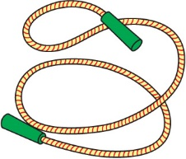  https://www.wiltssport.org.uk/get-informed/news/2944-skipping-videos-ks2  And/or  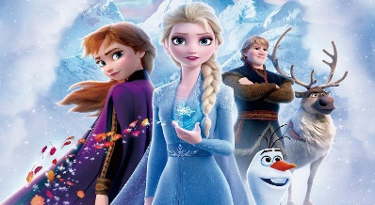  Learn to dance to the musical ‘Frozen’ with Oti Mabusi.  Please follow the link to:  https://www.youtube.com/watch?v=y0RGGDusyKI

English ideas
https://www.literacyshed.com/story-starters.html
Online dictionary -https://kids.wordsmyth.net/we/
Once upon a picture –story writing inspiration

Maths ideas:
Pixl –practise tables using the App
Nrich -https://nrich.maths.org/primary
Worksheets to practise tables: http://www.snappymaths.com/

Keeping active:
Cosmic kids yoga –mainly on Youtube check with an adult
GoNoodle -https://app.gonoodle.com/
The Woodland trust - https://www.woodlandtrust.org.uk/support-us/act/your-school/resources/
Joe Wicks daily work out

CBBC: has lots of programmes from ‘Horrible Histories’ to ‘Operation Ouch’

