School Closure Daily Planning- Garnet Class
DATE | Reading | Writing | Mathematics | Topic
Wednesday  20.1.21 | Scanning the text to help identify and understand new words  Today we are going to scan the text. Can you remember how to scan?  Scanning the text means we are looking for key words –words that may be new and tricky.  Can you find any words which are new? Can you underline the word and then find the definition? What is the impact of the word and why do you think the author chose it. Can you complete the worksheet which explores the definition, asks you to write a sentence and think about why the author chose it.  https://kids.wordsmyth.net/we/  Extension  Create a glossary for the opening two paragraphs | Oak Academy Grammar  Expanded noun phrases  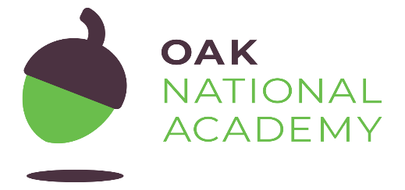  Please follow the link to the video and complete the learning challenges.  https://classroom.thenational.academy/units/t2-word-level-objectives-8c26  Extension  Using expanded noun phrases to describe two different monsters | White Rose Maths  Perimeter on a grid  Please can you follow the video and complete the work sheets.  https://whiterosemaths.com/homelearning/year-4/week-9-measurement-length-perimeter/  Extension  Reasoning question on perimeter | Greetings in German  Follow the lesson on SeeSaw and learn a song about German greetings  Extension  Find out facts about Germany  https://www.sciencekids.co.nz/sciencefacts/countries/germany.html

https://www.literacyshed.com/story-starters.html
Online dictionary -https://kids.wordsmyth.net/we/

Maths ideas:
Pixl –practise tables using the App
Nrich -https://nrich.maths.org/primary
Worksheets to practise tables: http://www.snappymaths.com/

Keeping active:
Cosmic kids yoga –mainly on Youtube check with an adult
GoNoodle -https://app.gonoodle.com/
The Woodland trust - https://www.woodlandtrust.org.uk/support-us/act/your-school/resources/
Joe Wicks daily work out

CBBC: has lots of programmes from ‘Horrible Histories’ to ‘Operation Ouch’

