School Closure Daily Planning- Garnet Class
DATE | Reading | Writing | Mathematics | Topic
Tuesday  12.1.21 | Ask questions to improve understanding.  (Shackleton)  In a text the main idea is usually in the first sentence.  Can you explain to someone at home:  1. What the text is about  2. What kind of text it is  3.How you know  4. What you like/dislike about it  5. What the main points from each paragraph are | Emperor Penguin  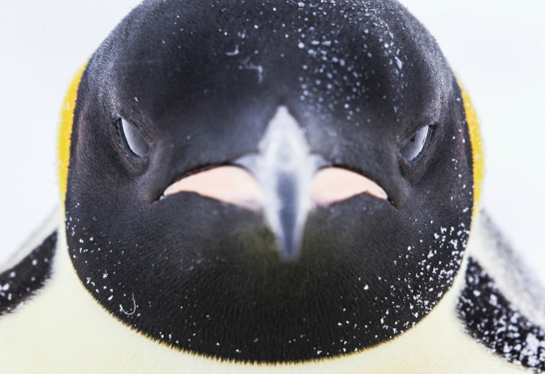  Question time!  What makes penguins so good at living in cold conditions? Can you think of other animals that live in such cold places?  Would penguins make good pets?  How do penguins learn to fish? What makes them good at swimming?  What is a penguin’s biggest threat?  Information and videos on Emperor Penguins  Watch the videos and make notes on The Emperor Penguin.  https://www.bbc.co.uk/teach/class-clips-video/science-ks1-ks2-wonders-of-nature-emperor-penguins/zm3ygwx  https://www.natgeokids.com/uk/discover/animals/birds/emperor-penguins/  https://animalfactguide.com/animal-facts/emperor-penguin/  Extension  Could you write a diary about a day in the life of an emperor penguin? | White Rose  Equivalent lengths –mm and cm  Please follow the link to the white rose video and complete the work sheets. Remember to complete the starter question.  https://whiterosemaths.com/homelearning/year-4/week-8-measurement-length-perimeter/ | 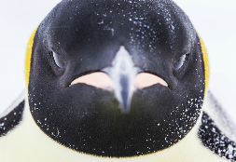  Perfect picture!  Imagine the camera zoomed out and you could see the whole penguin and everything around him. Can you draw a penguin?  You could also follow the YouTube video showing how to draw a realistic emperor penguin.  https://www.youtube.com/watch/Y1APW_4J8dw

More ideas to help with home learning
Writing ideas:
https://www.literacyshed.com/story-starters.html
Online dictionary -https://kids.wordsmyth.net/we/

Maths ideas:
Pixl –practise tables using the App
Nrich -https://nrich.maths.org/primary
Worksheets to practise tables: http://www.snappymaths.com/

Keeping active:
Cosmic kids yoga –mainly on Youtubecheck with an adult
GoNoodle -https://app.gonoodle.com/
The Woodland trust - https://www.woodlandtrust.org.uk/support-us/act/your-school/resources/
Joe Wicks daily work out

