School Closure Daily Planning- Garnet Class
DATE | Reading | Writing | Mathematics | Topic
Friday  15.1.21 | 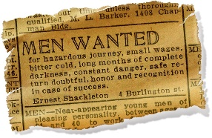  Infer, retrieve, summarise, compare and explain meaning  Follow the link to recap on how to make inference from the text.  https://www.bbc.co.uk/bitesize/topics/zs44jxs/articles/zqmyw6f  Can you complete the questions from the worksheet? | Can you create a fact file on your favourite polar animals?  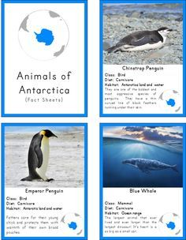  Twinkl has lots of information but you can also follow this link to find out more:  https://www.bbc.co.uk/bitesize/articles/z438cqt | White Rose Maths  Please watch the video and complete the worksheets on ‘Subtract lengths’  https://whiterosemaths.com/homelearning/year-4/week-8-measurement-length-perimeter/  Tables revision  Please practise your favourite table and your most challenging one. Can you use the Pixl app, maths frame or top marks? | Skipping Challenge  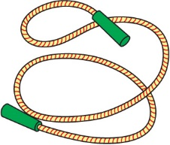  Please follow the link to take part in a skipping challenge with Dan the Skipping Man  https://www.wiltssport.org.uk/get-informed/news/2942-skipping-challenges  On the first page click on the blue ‘KS2’ button where there are videos on the challenge, how to skip and alternatives for skipping ropes. Below the 3 videos are links to the different challenges – can you practise the ‘single bounce’? You can go for bronze, silver or gold.

More ideas to help with home learning
Twinkl has free resources for parents
Writing ideas:
https://www.literacyshed.com/story-starters.html
Online dictionary -https://kids.wordsmyth.net/we/

Maths ideas:
Pixl –practise tables using the App
Nrich -https://nrich.maths.org/primary
Worksheets to practise tables: http://www.snappymaths.com/

Keeping active:
Cosmic kids yoga –mainly on Youtube check with an adult
GoNoodle -https://app.gonoodle.com/
The Woodland trust - https://www.woodlandtrust.org.uk/support-us/act/your-school/resources/
Joe Wicks daily work out

CBBC: has lots of programmes from ‘Horrible Histories’ to ‘Operation Ouch’

