Spring 1
Chatter Topics for
Onyx Class

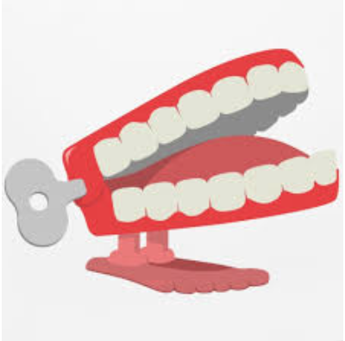
Chatter topic 1: What is art?
Chatter topic 2: Do you prefer 3d art (sculpture) or 2d art (painting or drawing)? Discuss why.
Chatter topic 3: Look at this picture. What do you think it represents? Do you like it?
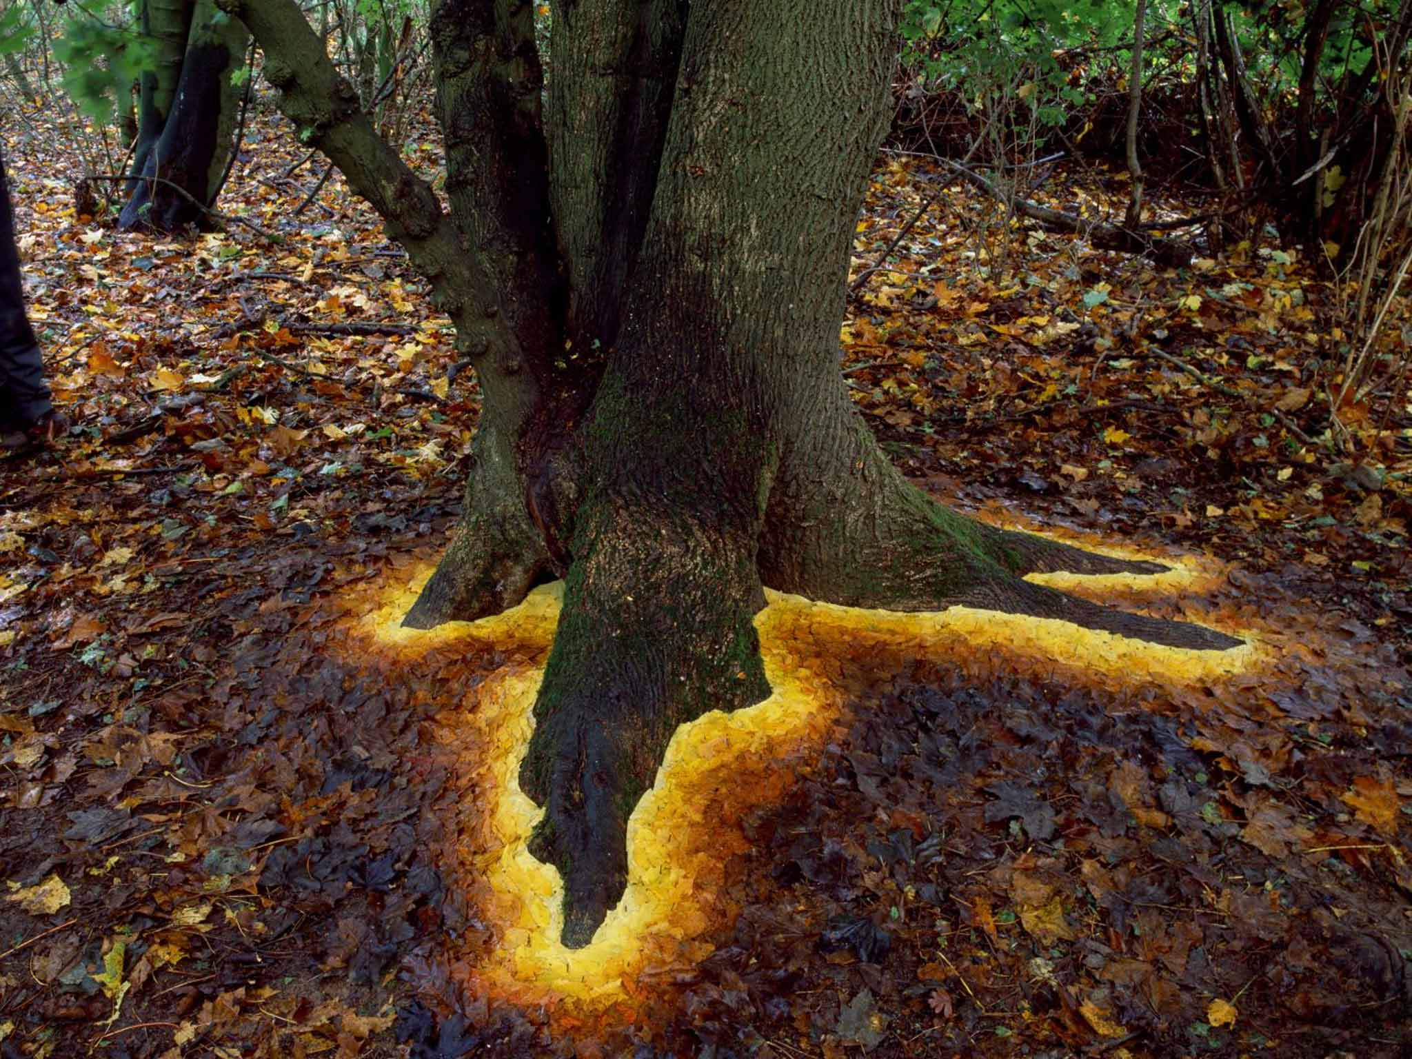
Chatter topic 4: Look at this sculpture. What title would you give the sculpture and why?
