C:\Program Files (x86)\Microsoft Office\MEDIA\CAGCAT10\j0215086.wmf**Autumn 2 Chatter Topics for** 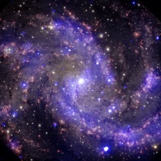

**Amethyst Class**

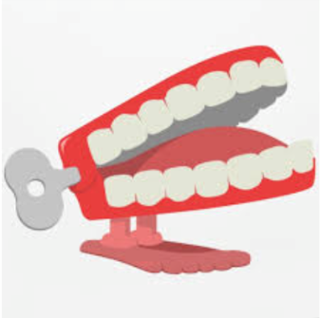

* **Chatter topic 1:** What do you feel when you look up at the night sky? What words would you use to describe the night sky to someone who has never seen ours?
* **Chatter topic 2:** What do you know about the planets? What are they made from? How do they move?
* **Chatter topic 3:** When was the last time you played with a construction toy [lego, k’nex, etc]? What did/could you make? Can you make it move?
* **Chatter topic 4:** If you were to visit a planet, which one would it be? Why?
* **Chatter topic 5:** Do aliens exist?