Autumn 2
Chatter Topics for
Garnet Class

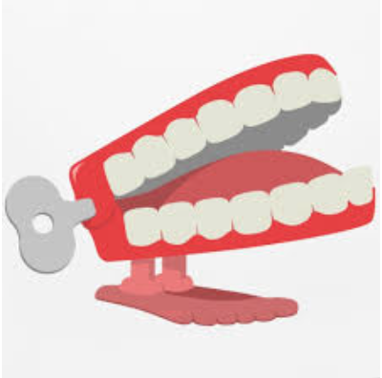
Chatter topic 1: Can one bit of light bounce off another bit of light?
Chatter topic 2: Can light bend round corners?
Chatter topic 3: What kind of objects make shadows?

Chatter topic 4: Can air make shadows?

Chatter topic 5: If you could see into the future, what would your house look like and what devises would you have?

