Autumn 1 Chatter Topics for
Onyx

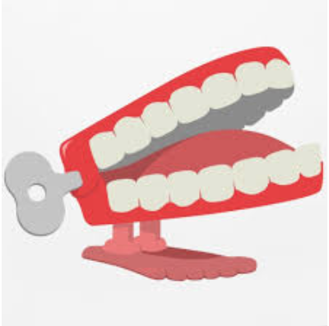

How does it feel to be back at school?

How is school different?

How is school still the same?

Do you think you have changed since Lockdown began and if so how?

What was good about Lockdown?

What was hard about Lockdown?

How can you help yourself to stay positive in future?

What are you looking forward to when life is back to normal?

