Autumn 1 Chatter Topics for
Crystal Class

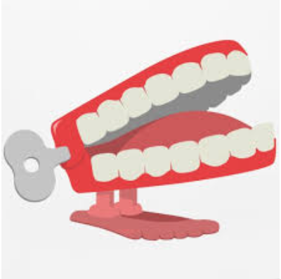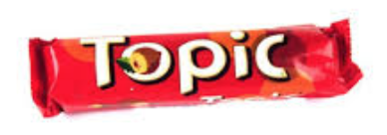
- Chatter topic 1: What’s your favourite smell? What’s the yuckiest thing you’ve ever smelled?
- Chatter topic 2: What’s your favourite weather? Why do you like that weather?
- Chatter topic 3: When was the last time you were silly? What did you do?
- Chatter topic 4: If you could be any pizza which one would you be?
- Chatter topic 5: What do you want to be when you grow up?

