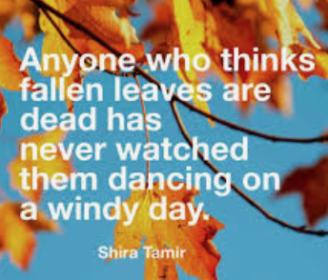
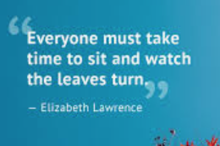

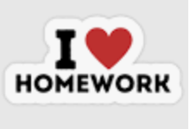 | Homework Options due on 19th October
Task 1 | Design a T-Shirt to represent happiness.
Task 2 | Draw or make a rainbow using any media you like – pens, paints, collage, pencils, chalk, lego, plasticine.
Task 3 | Try some mindful yoga – ask an adult to find this for you  www.cosmickids.com or  Moovlee Monkey on www.youtube.com
Task 4 | Draw a picture of people who you care about.
Task 5 | Make a card for a key worker to say thank you for all their help during Lockdown.
Task 6 | Paint a stone to add to our Verity the Viper stone snake which is outside the school entrance.
.

