School Closure Daily Planning- Crystal Class
DATE | Reading | Writing | Mathematics | Topic
Tuesday 23rd June | Aesop’s Fables – The Wolf and the Sheep.  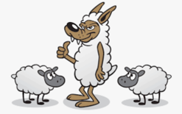  Answer the questions. | Missing Transitional Forms  Transitional forms are the living things that show the ‘in between’ stage between an ancestor and the modern living relative. While some were fossilised and have been found, others have not been. Artists use fossils to draw what they think the living thing would have looked like (the illustrations for dinosaurs for example).  Can you work out what the transitional form would have looked like for the following living things?  You can either draw and label your ideas or brainstorm your ideas. | Lesson 1  Add & subtract fractions  https://vimeo.com/418155222  Complete attached sheet | PE – 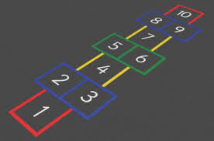  https://www.youtube.com/watch?v=aUi0V6_ROWA  How Do You Play Hopscotch?  1. Draw a traditional hopscotch diagram.  2. Throw a small stone, twig, beanbag, or other marker into the first square. (If it lands on a line, or outside the square, you lose your turn. Pass the marker to the following player and wait for your next turn.)  3. Hop on one foot into the first empty square, and then every subsequent empty square. Be sure to skip the one your marker is on.  4. At the pairs (4-5 and 7-8), jump with both feet.  5. At 10, hop with both feet, turn around, and head back toward the start.  6. When you reach the marked square again, pick up the marker—still on one foot!—and complete the course.  7. If you finished without any mistakes, pass the marker to the next player. On your next turn, throw the marker to the next number.  8. If you fall, jump outside the lines, or miss a square or the marker, you lose your turn and must repeat the same number on your next turn. Whoever reaches 10 first, wins.  5 Fun Hopscotch Variations  More challenging games linked to Hopscotch.  Watch The Time: Set the timer for 30 seconds. Each player must complete the course within the time frame to proceed. If you go into overtime, you lose your turn.  Sign On the Line: Instead of throwing the stone in numerical order, toss it in any square. When you complete a successful turn, initial the square where your marker landed and pass it to the next player. The game ends when all spaces have been initialed. The person with the most initialed squares wins.  Kick It: Try kicking the marker from space to space—with your hopping foot—as you jump through the course.  Name Categories: Label each hopscotch square with the name of a category (books, animals, pizza toppings, desserts, etc.). When you hop into a square, you must shout an item in its designated category. If you land in pizza toppings, for example, you might say pepperoni, mushrooms, olives, sausage, peppers, or bacon. You lose your turn if you can’t think of an item in that category, or if you repeat another player’s item.

Websites for additional work:

