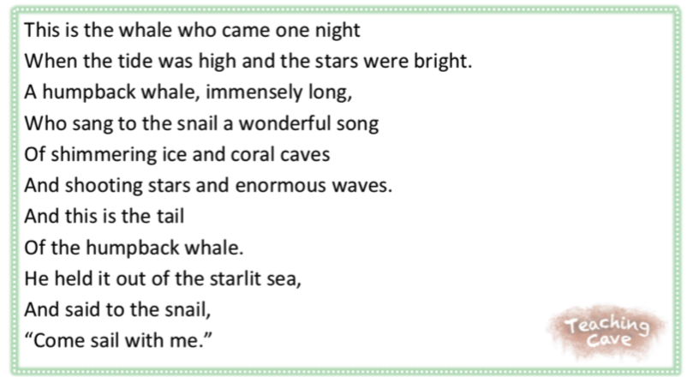
I found the a-e sound in________________.
I found the ou sound in________________.
I found the ai sound in________________.
I found the ly sound in________________.
I found the ar sound in________________.
I found the igh sound in________________.
I found the o-e sound in________________.
I found the i-e sound in________________.

