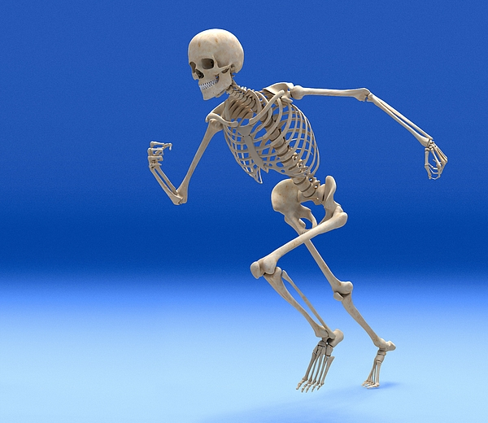

What keeps us alive?

Welcome to the final Summer term; we will continue to work from home and lessons will be uploaded each day via this website and on Seesaw. We will continue to use the White Rose Hub Maths Learning resources, set a daily reading and writing activity and also Topic, RE, PSHE and PE throughout the week.
This term we will be investigating ‘What keeps us alive?’. This will include studying how to eat a balanced diet and the importance of exercise. We will also be looking at why we have a skeleton and muscles and the basic parts of the digestion system. We will find out about why we have different teeth and how to look after them.
Please find a link to our topic webs below.
Part of our topic will be about exercise so while we are working from home, we would encourage the children to make sure they keep physically active. Joe Wicks continues to hold a great daily workout on his YouTube channel at 9.00am, the Go Noodle website also has lots of fun activities for the children to enjoy and Cosmic Kids is ideal for yoga.
Thank you for your support at this difficult time; we have really enjoyed your updates via Seesaw so please keep sending in all the lovely photos of the children and their learning. Please get in touch if you have any questions.

Websites:
What is a balanced diet?
https://www.bbc.co.uk/bitesize/topics/zrffr82/articles/zppvv4
Why is a healthy lifestyle important?
https://www.bbc.co.uk/bitesize/topics/zrffr82/articles/ztsqfcw
What does your skeleton do?
https://www.bbc.co.uk/bitesize/topics/z9339j6/articles/zqfdpbk
How do your muscles work?
https://www.bbc.co.uk/bitesize/topics/z9339j6/articles/zpbxb82
What is the digestive system?
https://www.bbc.co.uk/bitesize/topics/z27kng8/articles/z9wk7p3
The human skeleton
http://www.primaryhomeworkhelp.co.uk/skeletons/human.htm
Teeth facts
https://www.sciencekids.co.nz/sciencefacts/humanbody/teeth.html

