School Closure Daily Planning- Crystal Class
DATE | Reading | Writing | Mathematics | Topic
Tuesday 5.5.20 | Using the Mayan gods- find 5 unknown or interesting words. Complete 2 vocabulary grids with the headings: Word, Meaning, Image, Context. Use a dictionary to help you or ask an adult.  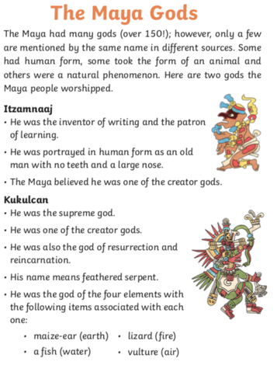 | Create a God factfile  Using the information you have learnt, your challenge is to create a fact file about Maya gods.  Make sure your information is clear and accurate and the pictures are bright and colourful.  Include:  Name of the god-  Meaning of the name –  God of –  Appearance –  Interesting fact –  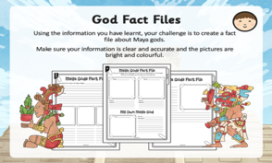  – use the attachment if you would like to as a guide.*, **, *** | 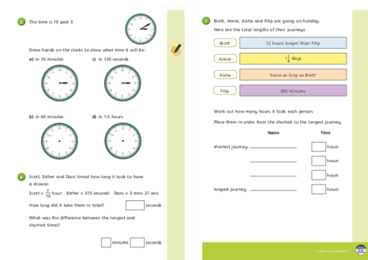  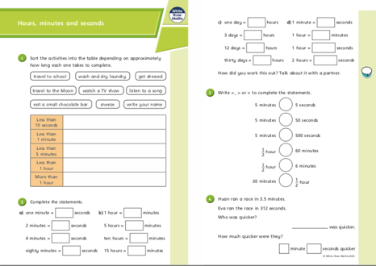  Hours, minutes and seconds. All  Challenge  Converting minutes into seconds – see attachment. | Design and make a mayan mask. Use the information about the Mayan gods to support you.  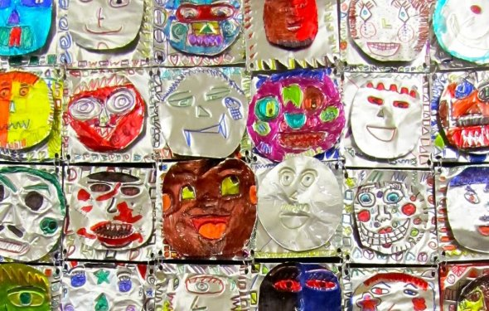  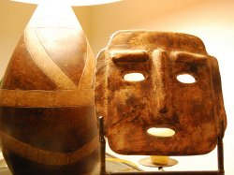  Connection to the Spiritual World  Most of the Mayan masks were symbols of their gods. Some masks were used for ceremonies, such as those worn by the Shaman. Many Shamans wore four kinds of mask, but others wore eight of them. Each of these masks represented a spirit. The masks may be human in form, but the design is attributed to personal spirits such as sharks, etc. Thus, the masks were a physical method of representing the spirit world.  Intimidate Enemies  It is also clear that many of these masks were used to intimidate their enemies, like those that have faces that look like snakes and similar kinds of animals. Those who believed in the powers of this mask because of its “spirit”, believed that it protected the wearer through spiritual power.  Ceremonies and Festivals  Masks were also used for wedding ceremonies and for other festivities - just like present-day masquerade ballroom events.

Websites for additional work:
http://the-maya.eu/MayaForKids/mayan-masks-for-kids

