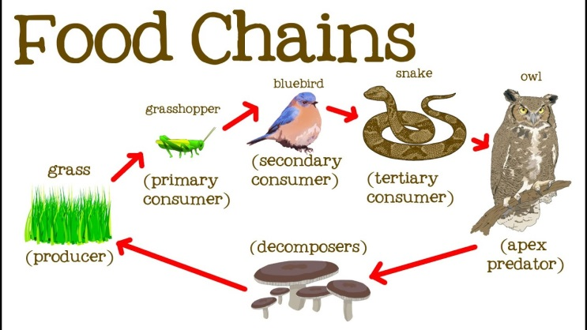

**Homework- Summer 6**

**Due in week commencing:**

**Do some exercise and draw a picture to show which muscles you used.**

**Record a food diary for a week.**

**Create a comic strip about a day in the life of a Roman.**

**Research an animal- find out how they are adapted to their environment. Don’t forget to draw a picture.**

**Look and a picture of your grandparents/ parents and you. How are you similar /different?**

**What makes us**

**human?**

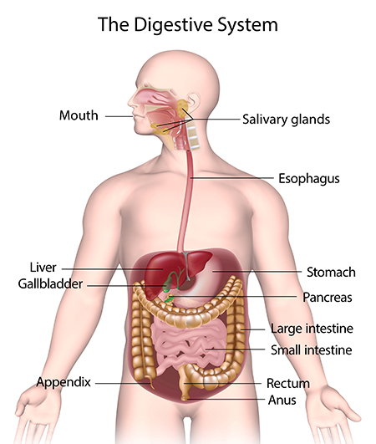

**Create a food chain to show where the energy goes.**

**Create 3D model of the digestive system.**