**PE**

Circuit training with Joe wicks

**Vocabulary**: **jumping jacks, squats, press ups**

**Computing**

* Coding using Scratch.
* Presenting work and ideas.
* Managing online information
* Privacy and security.

Key vocab: code, control, variables

**R.E- Christianity:** Do people need to go to church to show they are Christians?

- think about why people go to church

- look at special places to Christians

- Understand what a Baptism is.

- Understand what Holy Communion is.

|  |
| --- |
| Key Vocab: Baptism, Holy communion Christianity |

**English**

* Poetry
* Spellings
* Grammar
* Punctuation
* Extended writing linked to science
* I can spell the Year 3 and 4 words

**Languages- French**- Write or copy everyday words correctly.  
- Label items and choose appropriate words to complete short sentences.  
- Write one or two short sentences.  
- Write short phrases used in everyday conversations correctly.  
- Read and understand short written phrases.  
- Show awareness of the social conventions when speaking to someone.

**Learn 4 Life**

We will be focusing on

Mental wellbeing

Key Vocab: changes, well-being, mindfulness

**Topic- Science**

* Nutritional needs for animals and humans
* Describe how nutrients and water are transported within humans and animals.
* Identify the functions of a skeleton and muscles
* Describe the simple functions of the of the digestive system
* Identify the different types of teeth in humans and their functions.
* Identify how plants and animals, including humans, resemble their parents in many features.
* Recognise that living things have changed over time and that fossils provide information about living things that inhabited the Earth millions of years ago.
* Identify how animals and plants are suited to and adapt to their environment in different ways.

Key vocab: evolution, inheritance, nutrients

**Mathematics**

-Two/ three-digit number multiplied by a one-digit number

- Area and perimeter

- solving measures and money problems

-Shape: quadrilaterals and symmetry

-Position and direction

-Time

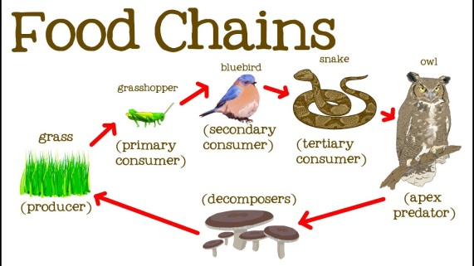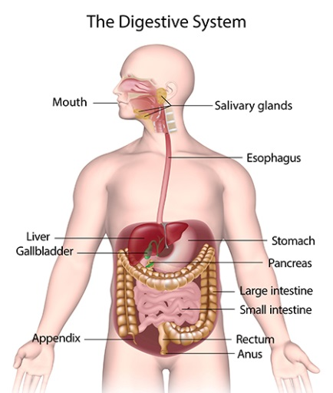

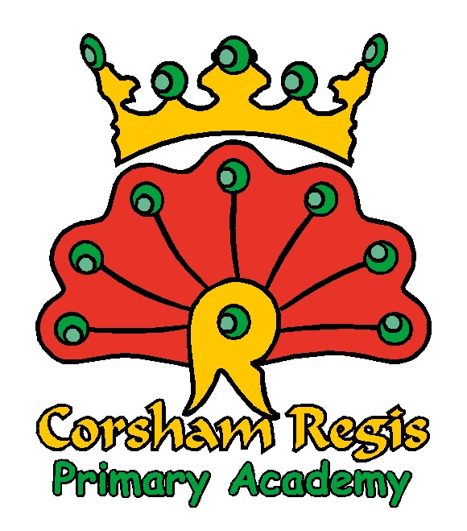What makes us human?