**PE**

* Dance/Go Noodle/Yoga/

Supermovers

* Up and Under

Key vocab: teammate opponent flexibility

**Learn 4 Life**

Ready, Steady, Go!

Getting ready for next year

Key vocab: change transition prepare

**RE**

**Islam**

Does completing Hajj make a person a better Muslim?

Key vocab: hajj pilgrimage mosque

**Computing**

Online safety  
Scratch coding

Key vocab: program de-bug

function

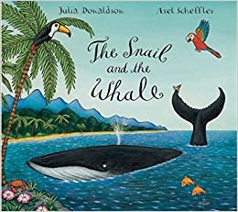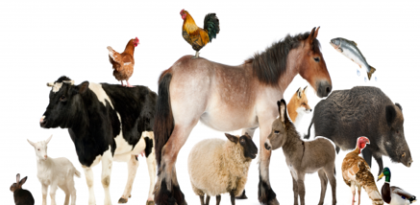

**Science: Animals**

* identify and name a variety of common animals including fish, amphibians, reptiles, birds and mammals
* identify and name a variety of common animals that are carnivores, herbivores and omnivores
* describe and compare the structure of a variety of common animals (fish, amphibians, reptiles, birds and mammals, including pets)
* identify, name, draw and label the basic parts of the human body and say which part of the body is associated with each sense.

Working Scientifically:

asking simple questions and recognising that they can be answered in different way / observing closely / identifying and classifying / using their observations and ideas to suggest answers to questions/ gathering and recording data to help in answering questions.

**English**

* The Snail and the Whale
* Phonics/reading skills
* Poetry – Oi Duck Billed Platypus

**What different types of animals are there and what do they need to survive?**

**Mathematics**

* Time
* Capacity and weight
* Problem solving