Onyx Class
Topic Questions Summer 2
Focus:  Science | Animals, including humans, ’What keeps us alive?’
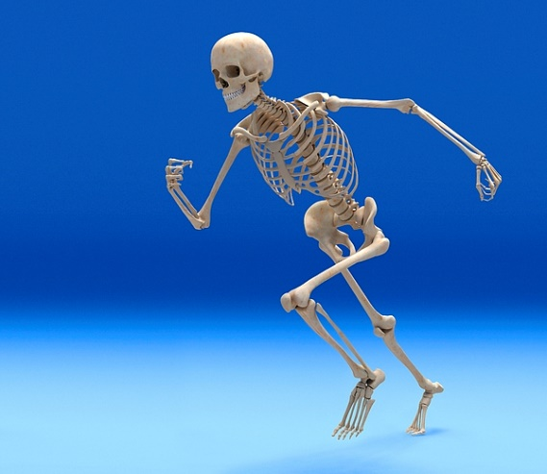

How do we stay healthy?
Can animals be grouped according to what they eat?
Why do humans and other animals have skeletons and muscles?
How do skeletons and muscles protect us?
How do my muscles work?
What is the digestive system?
What are the basic parts of the digestive system?
Why are my teeth different shapes?
Why do herbivores and carnivores have different shaped teeth?
How do I look after my teeth?

