Evolution and inheritance | What makes us human?
- What is inheritance?
- What is evolution?
- What are features of living things?
- What is the life cycle of a human?
- What is the life cycle of a plant?
- What does classification mean?
- How can plant and animals be classified into groups?
- What are the changes as humans develop from birth to old age?
- What are the different parts of plants?
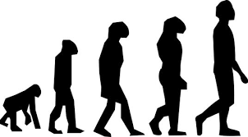
- What does reproduction mean?

