**P.E - Games:**

• Work alone, or with teammates in order to gain points or possession.

• Strike a bowled or volleyed ball with accuracy.

**Athletics:**

Compete with others and keep track of personal best. performances, setting targets for improvement.

**Vocabulary:** throw, refine, tactics, technique, accurate, pace.

Who were the Mayans?

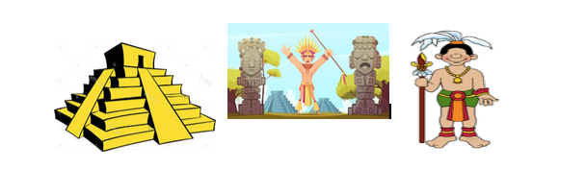

**Computing**

To code (using scratch)

**Vocabulary:** motion, looks, sound, draw, control, events, sensing, variables, operating.

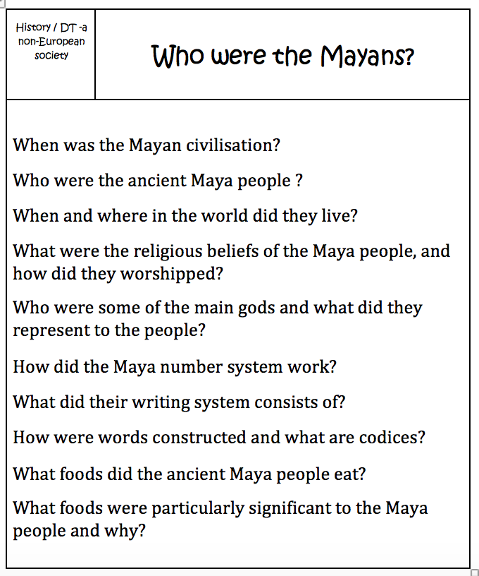

**History Milestones**  
• Compare some of the times studied with those of the other areas of interest around the world.   
• Describe the social, ethnic, cultural or religious diversity of past society  
• Seek out and analyse a wide range of evidence in order to justify claims about the past.

**DT Milestones**  
To design, make, evaluate and improve

• Design with purpose by identifying opportunities to design.  
• Make products by working efficiently (such as by carefully selecting materials).  
• Refine work and techniques as work progresses, continually evaluating the product design.  
• Use software to design and represent product designs.

**Vocabulary:**

Wow Day – A Mayan style picnic

**Learn 4 Life**

We will be focussing on Looking forward and Friends & Family.

**Vocabulary: embarrassed, changes, puberty**

.

**French/Spanish**

We will be working on producing a story using story maker. **Vocabulary: Centre- Ville, La Mairie, La Boulangerie, La Boucherie**

**English**

* I can write historical fiction
* I can write poetry
* I can present my work neatly
* I can choose layout devices such as headings, subheadings and bullet points
* I can use semi-colons, colons and dashes in my writing
* I can use cohesive devices to link paragraphs
* I can spell the Year 5 and 6 words
* I can edit and improve my writing, suggesting proposals to spelling, grammar and punctuation to enhance effects and clarify meaning.

**RE - Hinduism**

Do beliefs in karma, samsara and moksha help Hindus lead good lives?

Do religious people lead better lives?

Do all religious beliefs influence people to behave well towards others?

Is it possible to hold religious beliefs without trying to make the world a better place? **Vocabulary:** reincarnation, all power-ful, shun, Hindu.

**Mathematics**

* I can present my work neatly
* I understand place value in numbers up to 10,000,000
* I can read, write, order and compare numbers up to 10 000 000 and determine the value of each digit.
* Solve number and practical problems that involve large numbers, rounding and negative numbers.
* I can use formal written methods for addition and subtraction, multiplication and division.
* I can recognise equivalent fractions, decimals and percentages.
* I know all my times tables and

related division facts.

* I can solve problems involving the calculation and conversion of units of measure.
* I can apply my skills to solve problems.