School Closure Daily Planning- Crystal Class
DATE | Reading | Writing | Mathematics | Topic
Thursday 23rd April | Using the Maya Creation Story - find 5 unknown or interesting words. Complete 3 vocabulary grids with the headings: Word, Meaning, Image, Context. Use a dictionary to help you or ask an adult. | Go through the PPT – Meeting the Maya.  Your challenge is to create a ‘Welcome to the Maya Area’ tourist information page – a mini project for the next few days. The page must include details which questions:  - Who were the ancient Maya people?  - Where in the world did they live?  - What is special about the ancient Maya people?  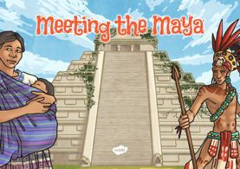  You can use maps and pictures on your page too. | Using your knowledge of the months of the year. Create your own questions for me to use tomorrow for the rest of the class. Do make sure you have worked through the questions and have the answers. | 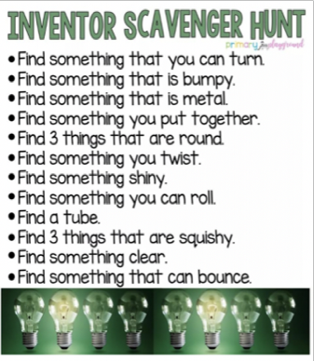

Websites for additional work:

