What did the Romans leave behind in Bath?

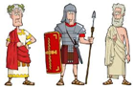
When was the Roman era?
Why was it called the Roman era?
Why were the Romans so powerful?
What customs did the Romans bring to Britain?
What was daily life like for rich Romans?
What was faily life life for poor Romans?
What did the Romans wear?
What religion did the Romans follow?
What were the Roman Baths in Bath?
What did the romans leave behind in Britain?

