School Closure Daily Planning- Crystal Class
DATE | RE | RE | RE | RE
RE Day  Hinduisim | Create a flow chart showing a consequence that follows the action and complete the flow chart, showing what the different choices could be. E.g. Sally is finding her homework difficult. What can she do? E.g. forget about it and go out with her friends/copy her friend’s homework the next morning/ask her teacher for help/research her homework on the internet, etc. | The game of snakes and ladders has its origins in Hinduism. It focuses on that doing a good deed will bring rewards but Hindus believe it might not be in this lifetime. In a lifetime, Hindus believe that people build up Karma, both positive and negative, based on their actions within that lifetime. This Karma affects their future lives and existences. People must take responsibility for their actions during this  life time and the next, therefore a belief in Karma has an effect on how a Hindu behaves. Collecting positive karma is like going up lots of ladders.  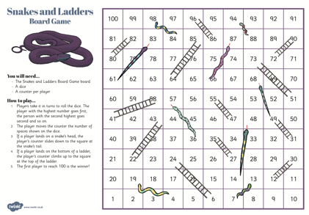  Make your own game of snakes and ladders. | Qu: How does a belief in Karma help Hindus lead good lives?  Hindus believe that the soul passes through a cycle of successive lives and its next incarnation depends on how the previous life was lived. Hindus aim to live each life in a better way than the life before, with this current life being like a passageway between lives. Hindus believe that the soul is eternal and lives many lifetimes, in one body after another. The soul (atman) can be born in a human form, or that of a plant or animal, as all living things have a soul (Brahman in everything).  Compare this idea of Samsara (reincarnation) with that of the Christian belief of life after death in Heaven.  Task - show the contrasts by drawing a straight line to represent  the Christian belief and label like a time line and draw and label a circle to represent the Hindu belief of life and death.  The spiritual goal of a Hindu is to become one with Brahman (Hindus’ belief in one God with many aspects). This freedom is called Moksha and until this  is achieved, Hindus believe that they will continue to be repeatedly reincarnated in order that they work towards self-realisation of the truth, that nothing else but Brahman exists). Once Moksha is achieved through various routes, the soul (Atman) is released to be united with Brahman. | Produce a piece of creative work e.g. art/ poem/collage/sculpture to express your own beliefs about what happens when the physical body dies.

Websites for additional work:

