**PE**

* Dance
* Yoga

Key vocab: balance rhythm flexibility

**DT**

* Design products for specific user/use
* Cut materials safely
* Measure and mark to the nearest cm
* Use a range of cutting and shaping techniques
* Use a range of gluing and joining techniques
* Make products, refining the design as work progresses.

Key vocab: design join measure

**Computing**

Online safety  
Scratch coding

Key vocab: program de-bug

function

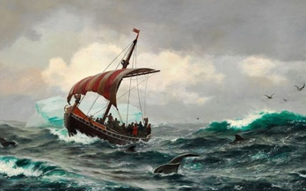

**Who were the greatest explorers of all time?**

**The focus for this term is History and DT**

**Skills taken from Milestone 1**

**English**

* News report
* Biography
* SPAG skills
* Handwriting
* Reading skills (VIPERS)

**History**

• Observe or handle evidence to ask questions and find answers to questions about the past.

• Ask questions such as: What was it like for people? What happened? How long ago?

• Use artefacts, pictures, stories, online sources and databases to find out about the past.

• Describe historical events.

• Describe significant people from the past.

• Recognise that there are reasons why people in the past acted as they did.

Use words and phrases such as: years, decades and centuries to describe the passing of time.

• Show an understanding of the concept of nation and a nation’s history.

Key vocab: timeline century nation

**Mathematics**

* Measure (length, capacity and weight)
* Time
* Fractions
* Position and direction