Friday | Reading | Writing
Morning Activity:  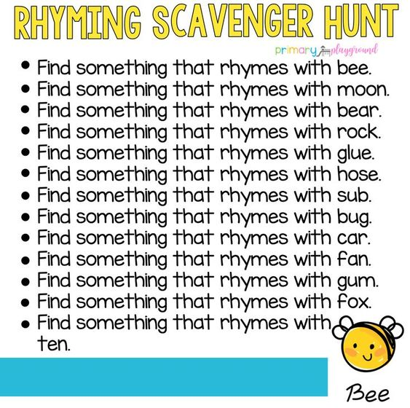 | Reading Eggs/Eggspress Lesson  Or  Read a book of your choice (Oxford Owl/home reading book/Oxford Reading Tree) and see if you can create a list of nouns that you find in your book.  Remember – a noun is a person, a place or a thing. This is a great song to help remember this: https://www.youtube.com/watch?v=JeognSU6wfU | Finish off any writing from earlier in the week. Get an adult to check for any spellings you need to practise.  Check that you have used the correct punctuation (?.,!)  When done, practise your Common Exception Word spellings using look, cover, write, check.
Maths |  | Topic
Equivalence between ¼ and 2/4  Watch Miss Denning’s video and see if you can find a way of proving that ½ is the same as 2/4 |  | Design a ship like the one Columbus sailed on to build next week.  Think about what materials you have to use and how you’re going to attach parts together. Remember, in the 15th century, they didn’t have modern technology!
Useful websites:
Little Bird Spellings from ICT Games https://www.ictgames.com/littleBirdSpelling/

