School Closure Daily Planning- Crystal Class
DATE | Reading | Writing | Mathematics | Topic
Friday  1.5.20 | Mark your learning from yesterday.  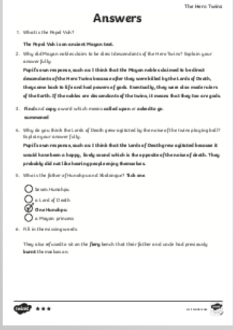  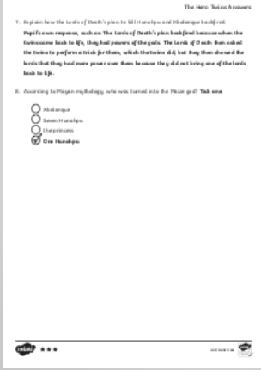 | The task today is to learn to use brackets, dashes or commas to begin to indicate parenthesis.  https://www.youtube.com/watch?v=bEl2qGZLuA0  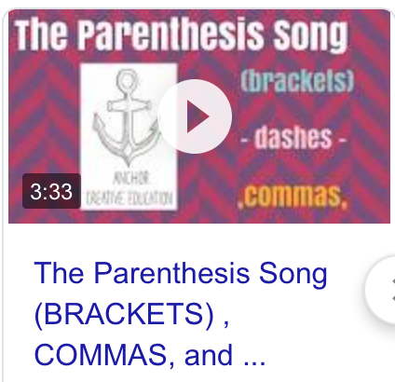  Task 1 – Design a poster with information on how to use brackets, dashes and commas.  Task 2 – Show me how you can use brackets, dashes and commas in sentences about something funny that has happened at home this week.  Task 3 – Challenge yourself with the questions attached. | Next week, we will be learning to tell the time. So in readiness, use an empty Easter egg box or a ceraeal box to make an analogue clock with moveable hands.  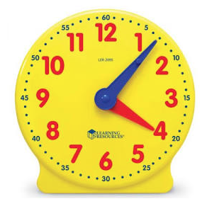 | 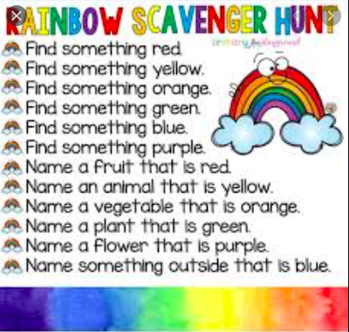  Friday fun with a rainbow scavenger hunt.

Websites for additional work:
https://www.youtube.com/watch?v=bEl2qGZLuA0

