Challenge:
Some of these problems involve remainders but children don’t need to know how to write this down yet.

16 4 = 18 9 =
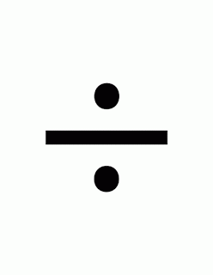
15 5 = 35 5 =
21 7 = 60 6 =
There were 23 children in the class. 6 children could sit at each 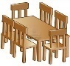 table. How many tables did they need?

Mrs Brown had 19 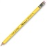 pencils. She could fit 5 into each pencil pot. How many pencil pots did she need?

The cat home has 38 kittens. 10 kittens can sleep in each 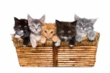 basket. How many baskets does the cat home need?

Sam had 44 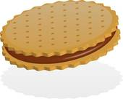biscuits. 11 biscuits can fit on each plate. How many plates does Ben need?

15 = 3 2 = 5
7 = 2 12 = 3

