A non-European society-  Who were the Mayans? | Who were the Mayans?
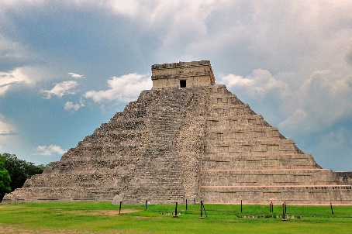
1.Who were the Mayans?
2. What are the religious beliefs of the Mayans people?
3. How did the Mayans worship?
4. How does the Mayan number system work?
5.What different sources of evidence can I use to find out about the ancient civilization?
6.What are Mayan cities really like?
7.What is the Mayan writing system like?
8.What Mayan inventions helped their civilization?
9.What everyday materials could you use to invent a gadget to help with everyday life?
10. Can you refine work and techniques by continually evaluating a products design?

