Target: To answer questions about a story.
There once was a friendly, little badger named Christopher. He lived under a hedge on the edge of a field. Christopher loved to learn new skills and there was nothing he enjoyed more than to make different foods for his friends to try.
One particularly cloudy day Christopher sat in his kitchen and wondered what treats he could make next to surprise his best friends, Philippa the pigeon and Andrew the hedgehog.
Christopher could not decide which treat he wanted to make that day.
‘Oh, will my friends like fried banana fritters with warm chocolate sauce or blueberry porridge?’ thought Christopher. ‘Or perhaps soft, creamy, vanilla fudge?’
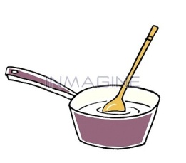
Finally, he decided to make the fudge. Christopher was happy and content in the kitchen so he whistled a loud, jolly tune while he stirred the ingredients together in a saucepan. Then, when he had finished stirring and checked that there were no lumps, he tried his best to put the fudge into a tray without spilling anything. Then he left it in the fridge to set.
‘Now I must ask my friends Philippa and Andrew to come and try my tasty fudge,’ said Christopher to himself. ‘Oh I cannot wait to share it with them, I hope the fudge sets in time!’
Extension
Well done! Now write the underlined words from the story into this grid.
What pattern can you see?
How many other words with this pattern can you list below?
Christopher’s Comprehension Superstar Checklist
Write in full sentences with capital letters and full stops.
A full sentence includes some information from the question.
You can not start sentences with ‘and’ or ‘because’.

What type of animal is the main character in the story? Tick your answer.
owl
badger
hedgehog
mole
pigeon

What was Christopher’s favourite thing to do?
__________________________________________________________________________________________________________________________
What could Christopher not decide on?
__________________________________________________________________________________________________________________________
Was the fudge mixture smooth or lumpy when it was finished?
__________________________________________________________________________________________________________________________
Where was the fudge left to set?
_____________________________________________________________
How did Christopher feel about sharing his fudge?
_____________________________________________________________
What do you think could happen next in the story?
__________________________________________________________________________________________________________________________

