School Closure Daily Planning- Crystal Class
DATE | Reading | Writing | Mathematics | Topic
Tuesday | Read the Maya Creation Story.  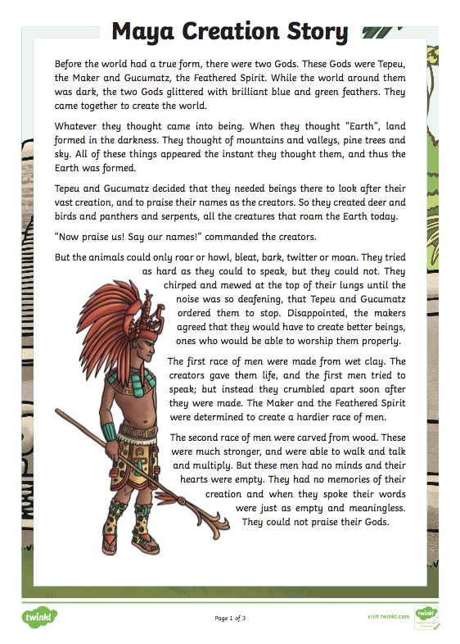  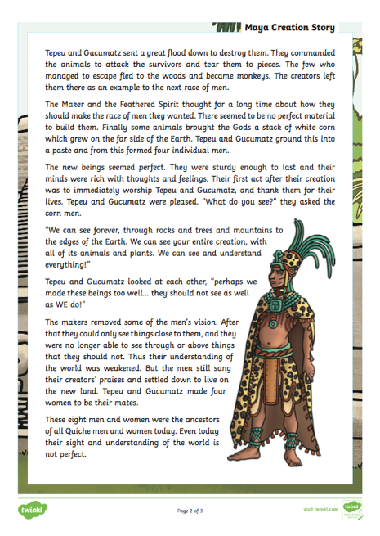 | COLD write – without any support from me or anyone at home write a playscript involving characters of your choice. | Mathletics – your choice | Use the internet to further research about the Mayan civilization.

