What was life like in Corsham during World War II?

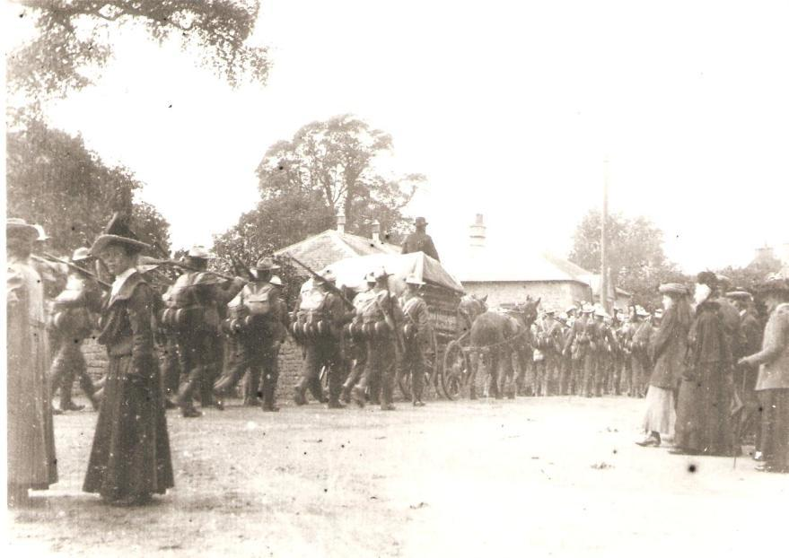
When was World War II?
Why did it happen?
Which countries were involved in the war?
How did life change in Corsham during World War II?
Which buildings in Corsham were used in the war effort?
Who were the land girls?
What was “The Blitz”?
Why were children evacuated to Corsham?
How do we remember World War II in Corsham?

