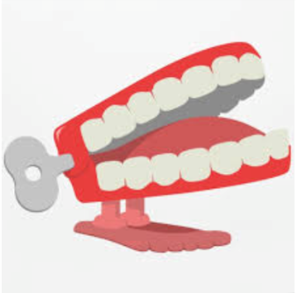

Question 1:
How has Corsham Changed over time?

Question 2:
What was Corsham’s role during the two world wars?

