Homework 2 – Name………….

Research the main news headlines from the 1970’s other than Mrs Doe being born.

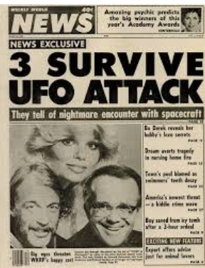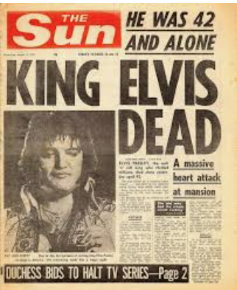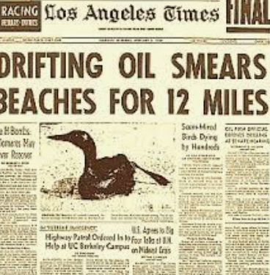

|  |
| --- |
| Research |