Homework 1 – Name………….

Research the fashion during the 1970’s and then design your own outfit.
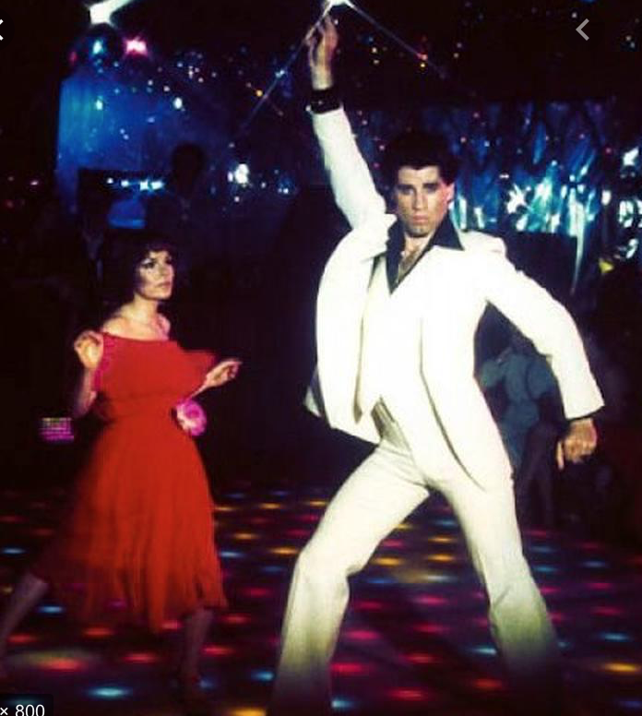
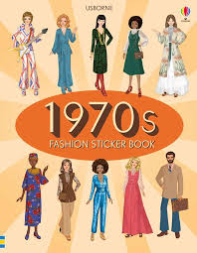
Research | Design

