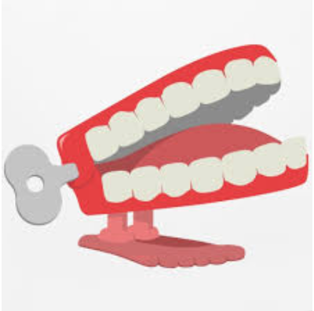

Question 1:
There were two kinds of bell bottom pants. One was called Bell Bottoms, but what was the other kind called?

Question 2:
Which movie symbolised the disco era and starred John Travolta in a white suit, one hand pointed to the sky?

