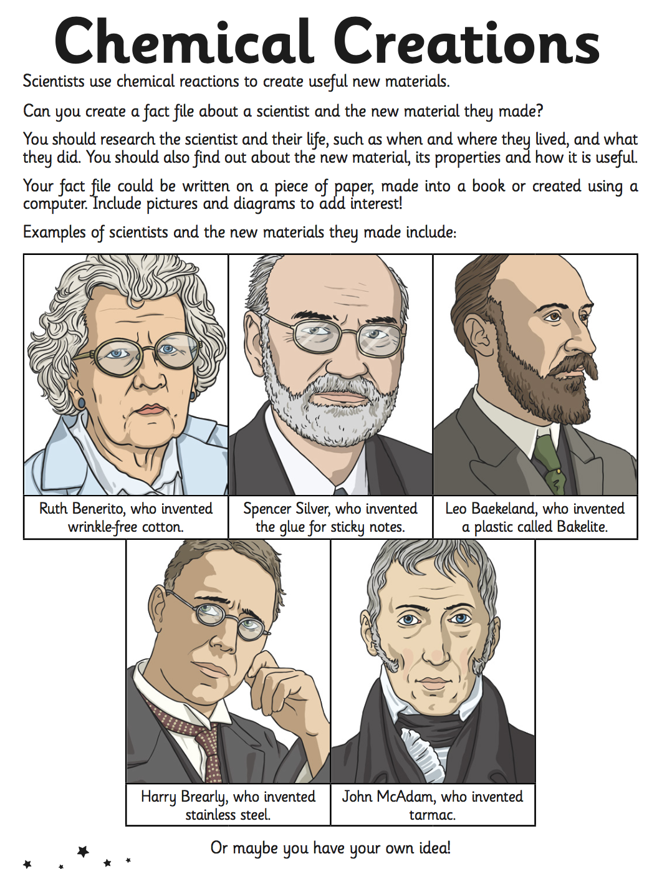

Crystal Class Homework 1

Name:

Date set: 8.11.19

Date due: 29.11.19